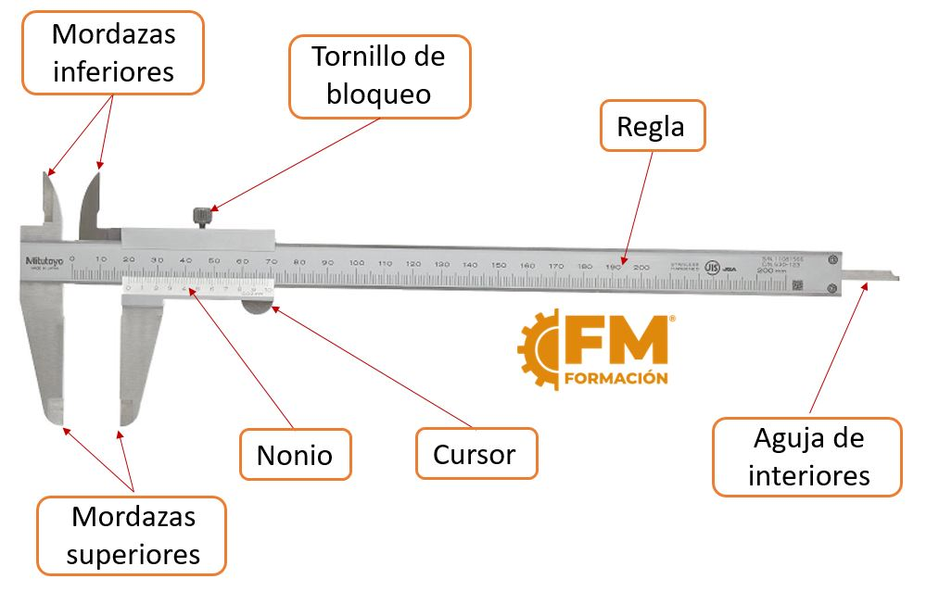

Referencias
- https://m.crealitycloud.com/blog/tutorials/how-to-3d-print
- https://www.impresoras3d.com/tipos-de-impresoras-3d/
- https://lohago3d.com/primera-parte-del-glosario-de-impresion-3d/
- https://youtu.be/VGwCrSP_oF0?si=z5-NviUOOsyfrjJd
- https://all3dp.com/1/artillery-hornet-review-3d-printer-specs/
- https://www.fabricacionmecanica.es/que-es-un-pie-de-rey/
- https://sites.google.com/ucar.edu/3dpaws/home

